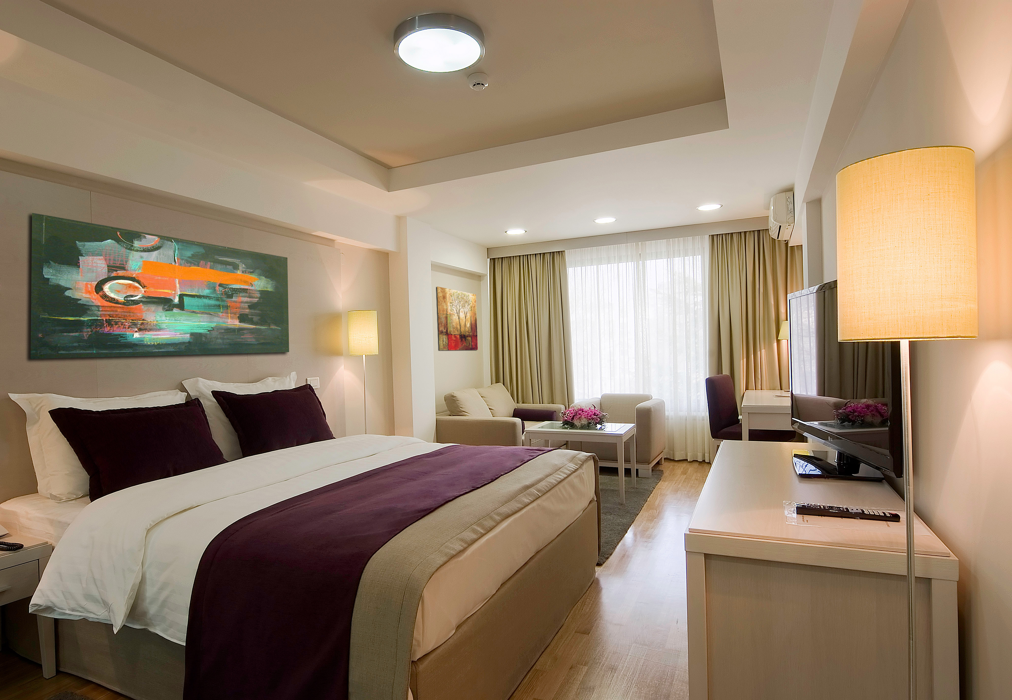

Accommodation Booking Form
Hotel M ****

ISD 2025, September 03-05, 2025.

A. PARTICIPANT’S DETAILS - please fill in capital letters
Title: | ☐Mr. | ☐ Mrs. | ☐ Other

*Surname: |  | *First name:
*Institution: |  | *Department:
*Postal Address: |  | *Postal code:
*City / State: |  | *Country:
*Telephone: |  | *Fax:
*E-Mail:

- ACCOMMODATION:
Room type | Single Use | Double use
Premier room | € 136.5 ☐ | € 153 ☐
Standard room | € 101.5 ☐ | € 118 ☐

Please complite the information requested:

Date/time of arrival: | Date/time of departure: | Nights: | No of Single Rooms: | No of Double Rooms:
You are sharing double room with
( name of your room mate):

Rate are in Euros on bed and breakfast bases. Tourist tax is included.
Further information and hotel description can be found on http: http://www.hotel-m.com/

- TRANSPORTATION – Airport / Hotel / Airport (rate - 40€ per person per way)
Arrival date: |  | Flight no: |  | Time: |  | No of persons:
Departure date: |  | Flight no: |  | Time: |  | No of persons:

D. PAYMENT:
☐ By credit card | ☐ Via Bank Transfer
☐ VISA Card | ☐ Master Card |  | ☐ American Express
_/_/_/_/_/_/_/_/_/_/_/_/_/_/_/_/ |  |  | Expiry date: _____/_____
CVC (card validation code): _/_/_/ |  |  | Name of the card holder: ________________________
(reverse side of the card, in signature field, last 3 digits)

*Note that signing the payment form is mandatory!
I hereby authorize MLADOST TURIST d.o.o to debit my credit card account with the total amount due and any subsequent changes (cancellation, and no-show charges) to the items booked.

*Card holder signature: _________________________

X Via Bank Transfer to the following account:
Payment instructions:
1 Internediary reibursement institution
BKAUATWW
2 Account with the company TP Mladost-turist d.o.o
BACXRSBG – swift code
UniCredit bank, Rajiceva 27-29, 11000 Belgrade, Serbia
3. Beneficiary costumer:
RS35170000030095232042 – IBAN CODE
Company: TP Mladost-turist d.o.o
Street: Bulevar oslobodjenja 56a, 11000 Belgrade, Serbia
Mention: ISD 2025
Please, contact us if you need a Proforma invoice. Payment of services should be made in EUR.

Bank charges are the responsability of the participants and should be paid at source in additional to the accommodation fees.
Please, make shure the name of the congress and the participant are stated on the bank transfer.

*Please notice that full payment will be charged by the T.P MLADOST TURIST D.O.O.

E. Cancelation policy for accommodation:
Until 27th August 2025. - no fee will be charged
Until 01th September 2025. - the cancellation fee is one full night's accommodation cost
After 01th September 2025. - prepayment will not be refunded
All changes /cancelations must be recieved in writing by fax or email to the Hotel M

Return completed Accommodation Booking Form with required payment to HOTEL M****:

Bulevar oslobodjenja 56a, 11000 Belgrade, Serbia
Phone / Fax: +381 11 3090 643
E-mail: events@hotel-m.com

